Communication and Clarification
Using Symbols as Signifiers in Modern Archaeology

Jennifer McAninch

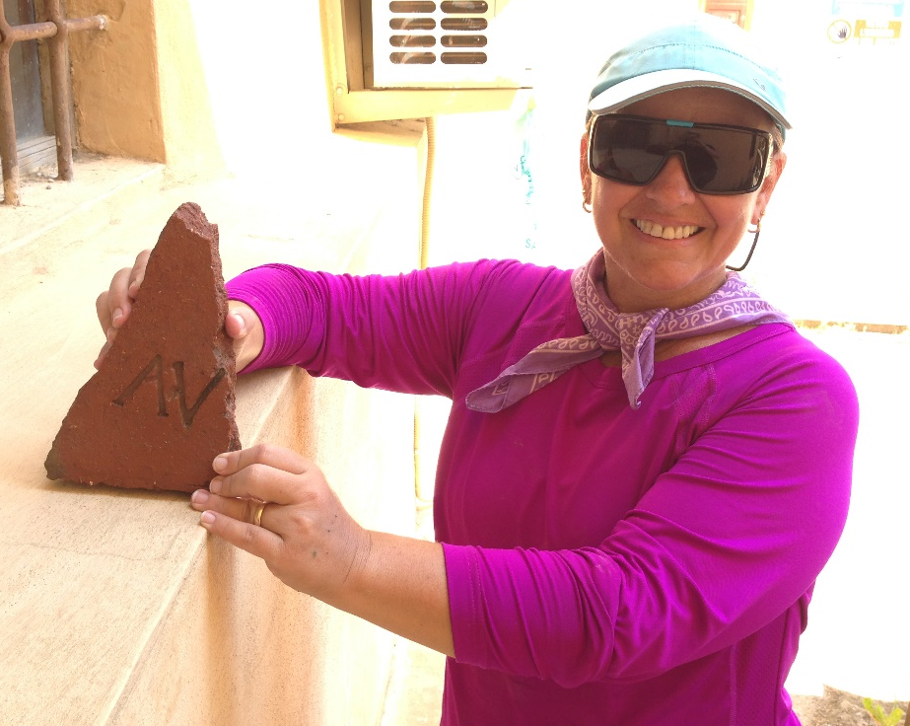

Professor Carolina Megale
25 July 2015
The modern archaeologist must use techniques garnered from multiple disciplines. The foundation for this methodology was constructed by W.M. Flinders-Petrie, whose nineteenth century excavations in Egypt revolutionized the study of ancient civilizations and helped to establish the modern archaeological process. Scientific method is applied in order to create a hypothesis regarding the function of a dig site, to analyze objects, and to categorize the findings. Mathematics is used to structure the grid system and to create labels for multiple stratified layers. Chemistry is also useful in understanding components within the soil and, in very ancient sites, carbon dating is invaluable. All of these elements enrich the knowledge gained about a given site, but an equally important tool is visual discrimination. An archaeologist must be able to recognize patterns, discern layers and interpret the signs and symbols left by the inhabitants. These signifiers speak clearly, even over many millennia. They communicate a wealth of information to those able to recognize and understand them.
The use of symbology has existed almost as long as man has walked the earth. The need to communicate ideas is an essential survival skill. Mankind has made use of a multitude of media in order to fill this need. From the cave paintings at Altamira, to the Petroglyphs of Mesoamerica, symbols were constructed and comprehended. As time progressed, symbology evolved alongside community, the range of images became wider and the system more complex. By the time the first cuneiform tablets appeared in Mesopotamia, these significant symbols had progressed from simple ideograms to a complex phonetic system. Writing and reading were developed and the use of language rapidly spread. These methods of communication provide a wealth of information about the civilizations that produced them: “At issue here is a concern central to archaeology itself: the interpretation of material culture and its patterning across space and time. Understanding past cultural experiences and events through the idiosyncratic, partial, and highly variable archaeological record requires more than simply bridging temporal and cultural distance but an epistemological leap of faith about the certainty of one’s conclusions.”
Deciphering the images discovered at an archaeological site is a process akin to forensic detection. Each civilization has symbols in common, but the use and execution of each image may also be associated with the region and era in which they were created. Noting the absence of certain common objects or symbols can also provide clarification. These variations help the archaeologist to determine very specific information, often illuminating details that cannot otherwise be established: “Types that once seemed widely different are found to be connected by intermediate ones; and a continuous line, reaching back through ages, has in many instances been formed by the recovery of missing or of hitherto misinterpreted evidence.” The archaeologist, therefore, must be a keen observer, able to discern miniscule relationships between superficially dissimilar objects. Equally important is the ability to recognize the absence of parallels which indicate a separation between one culture and another.
A single symbol communicates a wealth of information. Initially, it is representative of the culture for which it was designed. The material construction speaks of resources and availability, either found in the immediate area or imported as a product of trade. The quality and craftsmanship of the symbol may be connected to the wealth or social status of its owner. The size and shape may relate to its significance within the society. The location of the symbol and its relationship with the immediate surroundings may indicate function. Symbols may also provide clues to chronology of the dig site. The symbol can be compared with those found at other sites to determine if there are connections beyond a single location. In exceptional cases, symbols may identify their owner or even their creator. Careful consideration is the key to understanding the language of images and symbols.
As an example of the practical application of symbology in modern archaeology, consider the recent excavation that took place at Piazza Garibaldi in Fiesole, Italy. Among the materials excavated were a large number of terracotta roof tiles. Located within the rubble, two roof tiles with stamped symbols were discovered. Their color and consistency was similar, with irregular inclusions and an overall rough texture. The stamped symbols were identical and consisted of two clearly defined letters, “AV”. The letters were both capital with a serif font. The two tiles were found at opposite ends of a peristyle that had collapsed, approximately 10 meters apart. They were uncovered within layers of similar stratigraphic composition. Both tiles had been fractured, either at the time of the collapse or during the excavation process. The first tile was triangular in shape and no other pieces were recovered. The fracture occurred immediately after the “V”, making it impossible to determine if other letters followed. The second tile was found in several pieces. There was a break between the two letters, but the space to the right of the “V” was visible, making it clear that no other letters were imprinted with the stamp.
The significance of the symbol stamped on the bricks has yet to be fully evaluated. Initial hypothesis is that they may identify either the manufacturer or the owner of the structure. The discovery was made on an established archaeological site, under the direct supervision of experienced archaeologists, using the appropriate scientific structures and a system of mathematical grids to record the findings. This clinical environment greatly increases the likelihood that the discovery of the symbols on the roof tiles will enhance understanding about the history and use of the site. This simple symbolic image, “AV”, has the capacity to provide a wealth of information about a building that was erected during the Roman Empire. The stamp serves to illustrate the power that can be contained in a single symbol.

Works Cited

- S. Y. Stevenson, "Archæology 1880-1892." Science 20, no. 510 (Nov. 11, 1892): 267-269.

- Alexander A. Bauer. "Objects and their Glassy Essence: Semiotics of Self in the Early Bronze Age Black Sea." Signs and Society, no. 1 (Spring, 2013): 1-31.

- Jennifer Tucker. "The Historian, the Picture, and the Archive." Isis 97, no. 1 (March, 2006): 111-120.

- Rex Welshon. "Working Memory, Neuroanatomy, and Archaeology." Current Anthropology 51, no. S1, Working Memory: Beyond Language and Symbolism (June, 2010): S191-S199.

Bibliography

Bauer, Alexander A. "Objects and their Glassy Essence: Semiotics of Self in the Early Bronze Age Black Sea." Signs and Society 1, no. 1 (Spring, 2013): 1-31.

Stevenson, S. Y. "Archæology 1880-1892." Science 20, no. 510 (Nov. 11, 1892): 267-269.

Tucker, Jennifer. "The Historian, the Picture, and the Archive." Isis 97, no. 1 (March, 2006): 111-120.

Welshon, Rex. "Working Memory, Neuroanatomy, and Archaeology." Current Anthropology 51, no. S1, Working Memory: Beyond Language and Symbolism (June, 2010): S191-S199.

S. Y. Stevenson, "Archæology 1880-1892." Science 20
Alexander A. Bauer. "Objects and their Glassy Essence: Semiotics of Self in the Early Bronze Age Black Sea." Signs and Society
Jennifer Tucker. "The Historian, the Picture, and the Archive." Isis 97

